Ain’t that a Bite Design Doc

Game Overview

Description
Ain’t That a Bite is a top-down tower defense in which the player plays as a pilot protecting their plane . The player can move their character around shooting zombies themselves, and build towers with various beneficial effects.

Aesthetic
The game will be set in the 1950’s, using a low poly art style. The player character will be a pilot dressed in the style of this time, and the map will be set in a city. The zombie types will vary in look, with the basic type of enemy looking like the traditional zombie seen in most media. The different types of zombie will look significantly different, with some much larger with built up bodies, and some spewing toxins. The general tone of the game will be fairly lighthearted, with exaggerated character designs and little to no gore.

Core Gameplay
The core gameplay loop will consist of the player placing down some towers with their starting money before the waves of zombies begin. The zombies will travel towards the central objective, going along routes next to where the player has built towers. Any zombies that reach the objective will do damage, and when the objective’s health reaches zero the player loses the game.
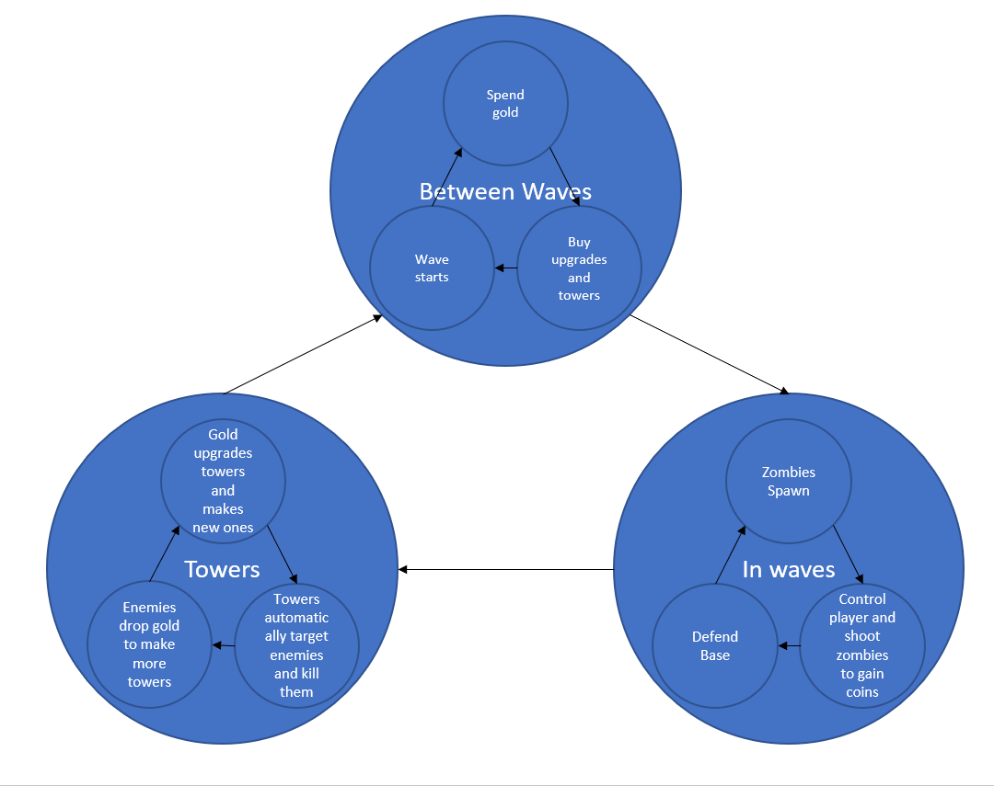
Core loop (Jake Rowland)
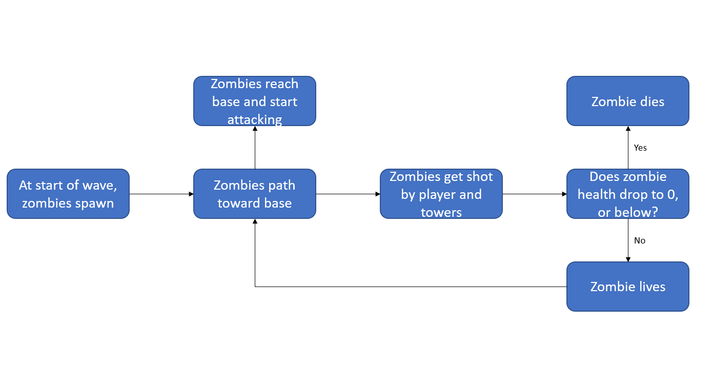
Zombie Loop (Jake Rowland)

Inspiration

Theme / Style
The game’s setting will be a low-poly city in the 1950’s, with levels set in different parts of the city.
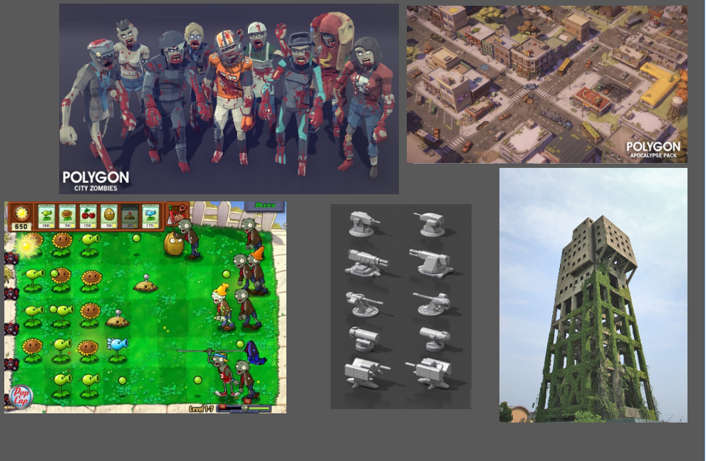

Theme moodboard (Liam Bird)

Mechanics
The game will take inspiration from both twin-stick shooters and tower defense games for its mechanics.
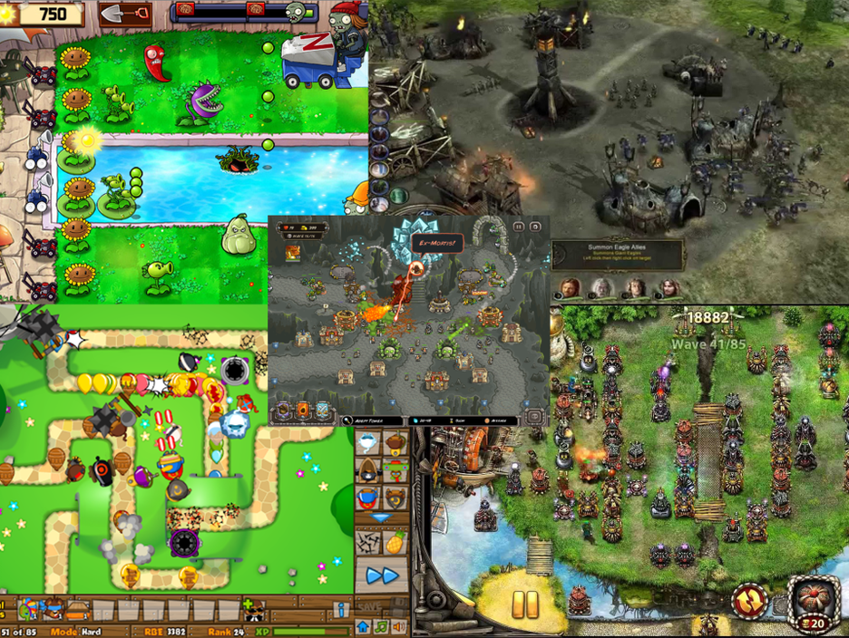
Mechanics moodboard (Liv Wall)

Features

Must Have
- Movement w/left stick
- Shooting w/right stick
- Basic placement of towers in a certain area
- Basic zombie that walks towards center
- Basic turret
- Objective w/health
- 1 map

Should Have
- Bomb tower
- Multiple waves
- UI for tower spawning
- UI for wave number
- Zombie that targets player with ranged attacks
- Coins gained from killing zombies to build towers with
- Coin UI

Could Have
- Multiple player weapons
- Pickups that increase objective health
- Tower health
- Enemies that attack towers

Would Have
- More tower types
- Upgradable towers
- More types of zombie

Mechanics / Systems

Player Character
The player character will control in a similar way to a twin stick shooter, with movement on the left stick and aiming on the right stick. While the right stick in pressed in a direction, the player will automatically shoot in that direction. The player character does not have health, with them instead protecting a central objective whose health they must maintain. The player’s weapon will do less damage than their towers, but is able to be aimed freely and moves with the player.

Enemies
There will be several different types of zombie, which will spawn in increasingly large numbered waves and approach the central objective. If any reach the objective, they will do damage, the amount of which varying between types of zombie, and disappear. Certain zombie types will target the player, giving them a debuff such as being unable to move for a short period of time if they hit. The speed of most zombie types will be fairly slow, with some moving significantly faster. When the player or one of their towers kills a zombie, they will receive a number of coins relative to the zombie’s type.

Towers
The player can build towers in certain spots around the map, with each costing a different amount of coins. The towers have varying effects, with some shooting enemies in a certain radius around them, some doing AOE damage in the space around them at set intervals, and some giving passive buffs to the player. The towers can also be upgraded to increase their potency, costing additional coins.

Levels / Areas
The game is set in a city, with the zombie waves coming from a few set points at the edge of the map. The spots for towers to be built are near these entrances, with paths built for the zombies to walk to the objective.

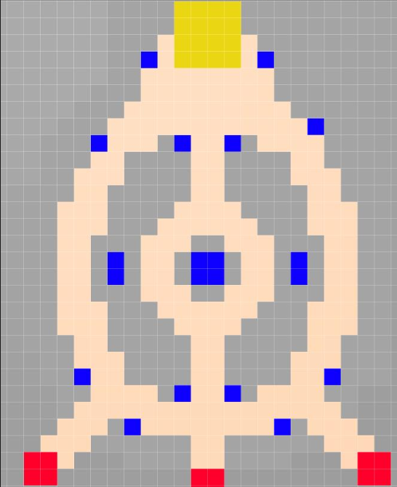
(sketch by Jake Rowland)
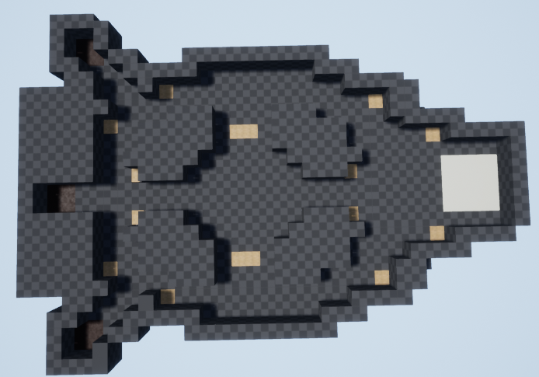

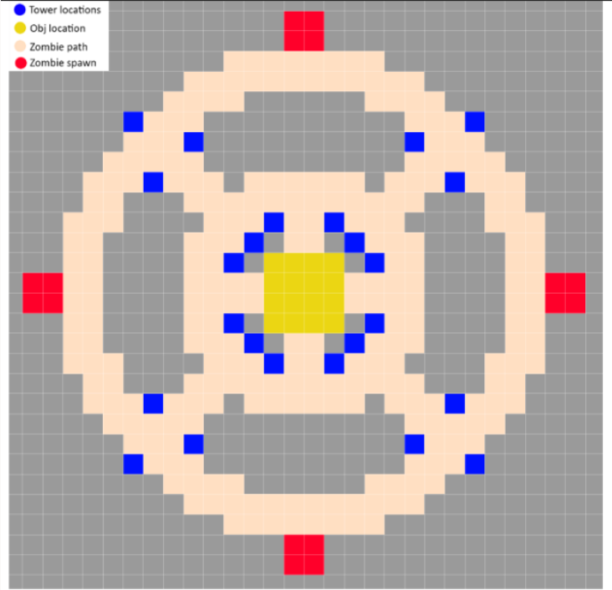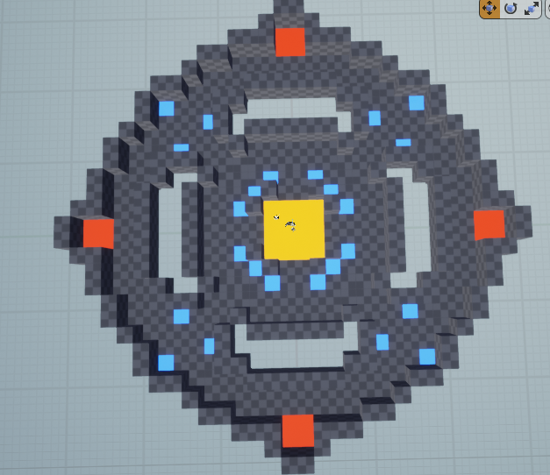
(Jake Rowland)

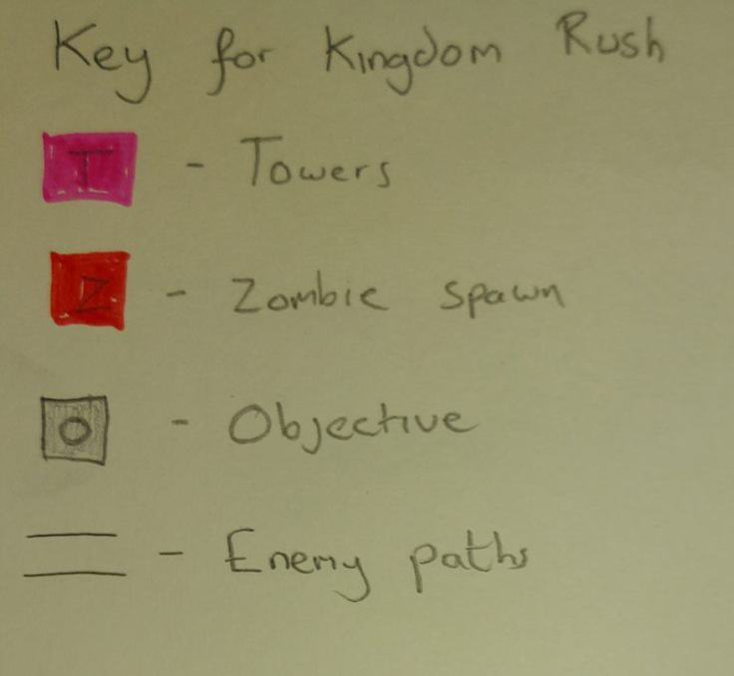
(Liv Wall)
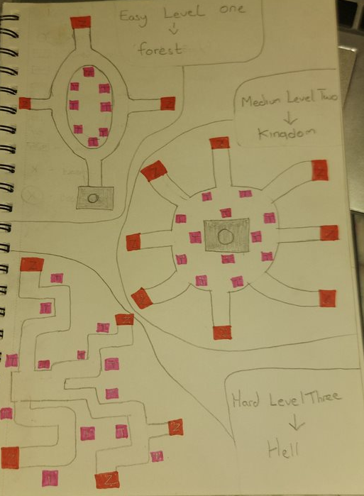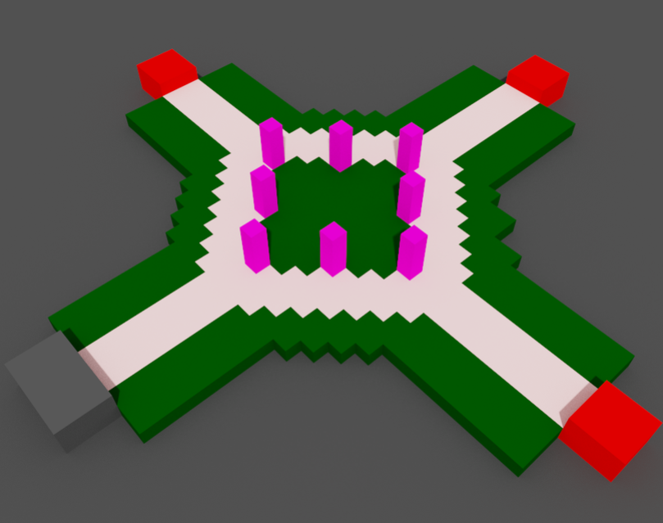

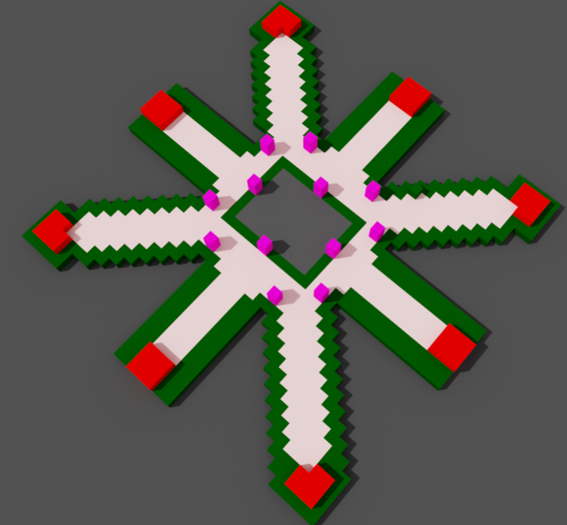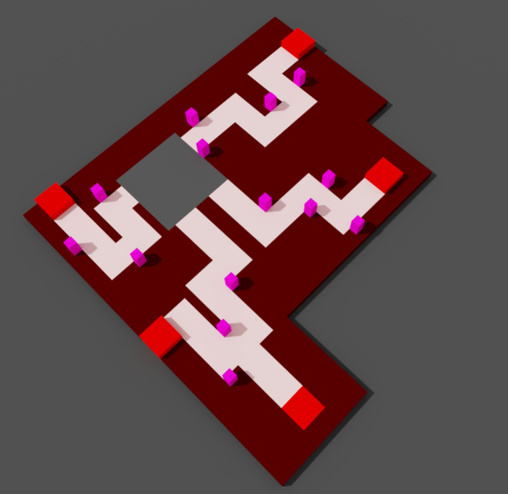

(Liv Wall)

